Subject: Horsham District Virtual Jobs and Skills Fair today, Chesworth Farm receives Local Wildlife Site accolade and much more news

All the latest news and information from Horsham District Council

Having trouble viewing this email? View it as a Web page.
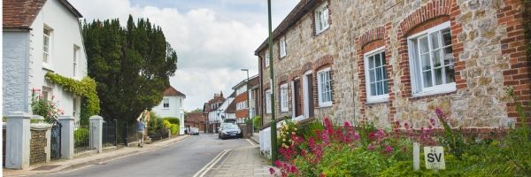

Latest news

and information


Come along to the Virtual Jobs and Skills Fair today
Visit the Virtual Jobs and Skills Fair website today between 10am-3pm and meet loads of local and national employers with hundreds of opportunities available. Plus, get expert tips on improving your employability skills.

Visit Jobs Fair

Chesworth Farm receives Local Wildlife Site accolade
Chesworth Farm has officially been designated as a Local Wildlife Site, joining other council-owned sites such as Leechpool & Owlbeech Woods, Monkmead Woods and Southwater Country Park.
Local Wildlife Sites are non-statutory sites that contain features of substantive nature conservation value. In Chesworth Farm’s case these are the extensive high quality hedgerows and wildflower meadows.

Read more

Join the Great British Spring Clean
Join Keep Britain Tidy's annual litter campaign, the Great British Spring Clean, and help improve the environment on your doorstep.
This year our outdoor spaces and places have mattered more than ever before. They have been a sanctuary during challenging times, so it's time to repay the favour.
Follow the button below to find our how you can get involved.

Get involved

Leisure activities starting up again
As we cautiously ease out of lockdown, we are pleased to say that many of our leisure activities are starting back up again.
Our free, sociable, and family friendly guided Wellbeing Walks are resuming from 1 May.
Reaching Higher Athletics sessions for children and young people with additional needs and their siblings are resuming from 5 May and you can book online.
The popular Horsham Wheels for ALL inclusive cycling sessions for people with additional needs have started back up.

Census 2021: There's still time
The Office of National Statistics have said that although 9/10 people have completed the census, there's still time to respond if you haven't yet.
If you need assistance, please call 0800 141 2021 or visit the nearest support centre.

Complete the Census

Stay connected    Parkside, Chart Way, Horsham,  West Sussex,  RH12 1RL | 

Contact Us | Manage Preferences | Unsubscribe | Help

