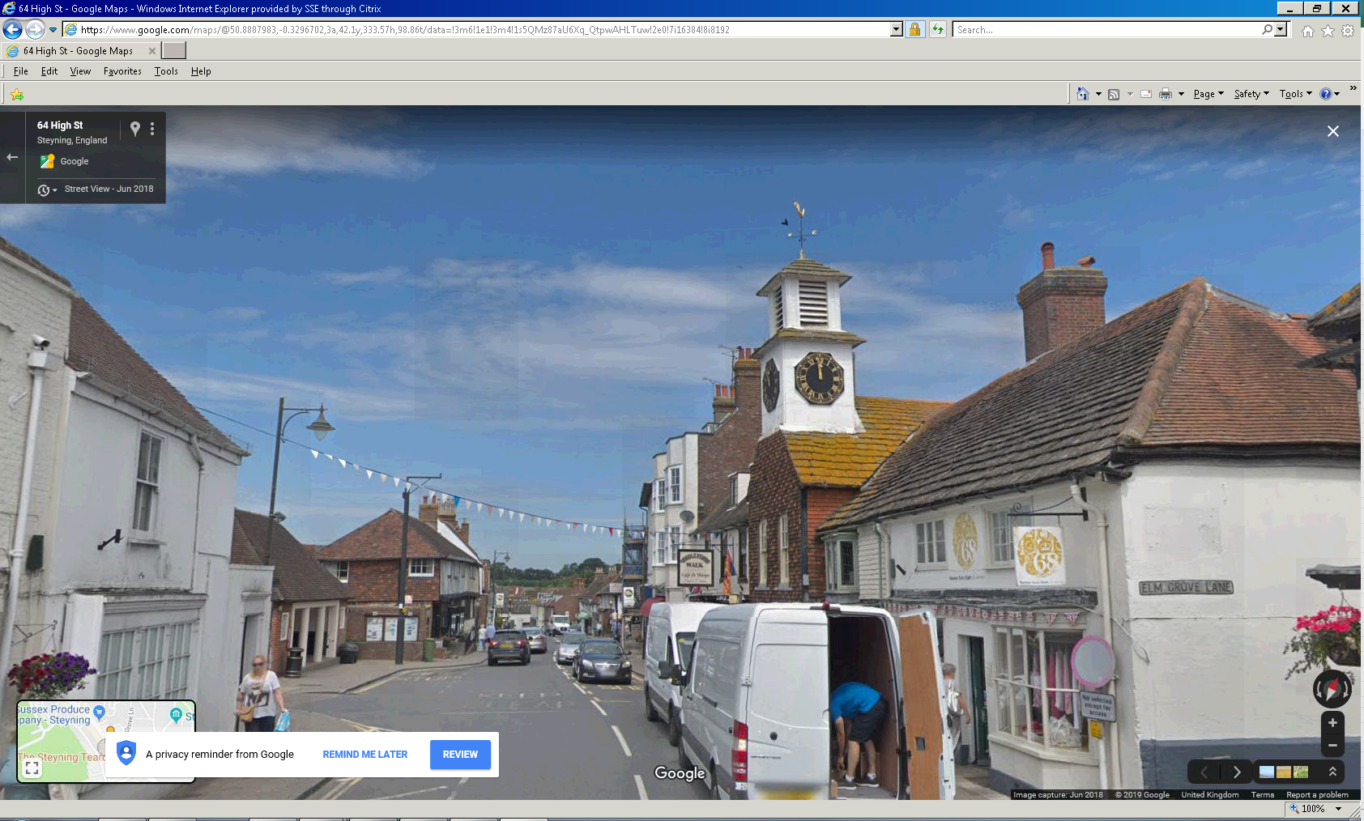
No spot lights this clock face
Spot on column lights clock face on front
Spot on wall used to light clock face on side

