Memorial Playing Field.
Community Orchard report
Our headline photo shows the tree donors and families on our first tree planting session on the Community Orchard in February. We planted 4 trees : two Pears (Beth and Concorde), a Plum (Warwickshire Drooper and an Apple (Michaelmas Red).
Then the following week two more tree donors planted 2 more Apples (Margil and Herefordshire Russet). We have now planted 22 new trees here. 14 Apples, 3 Plums, 4 Pears and a Quince, all of which have been donated and planted by local people and their families.

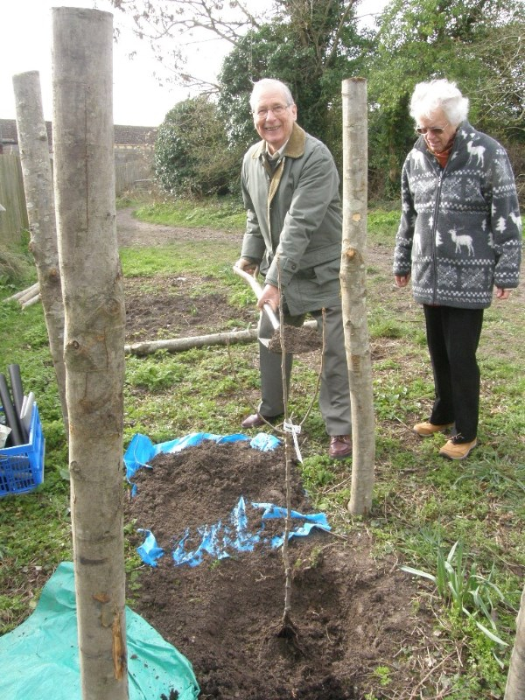
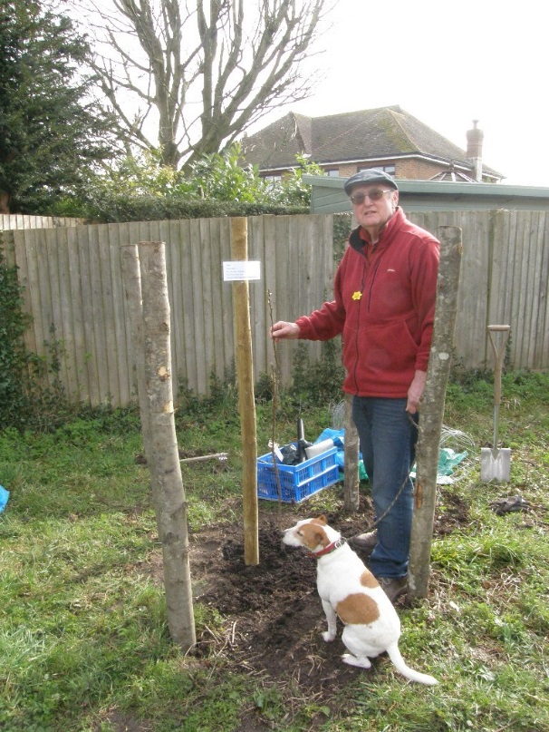

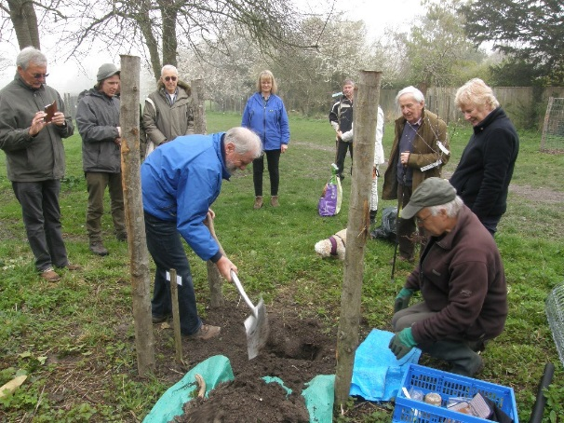
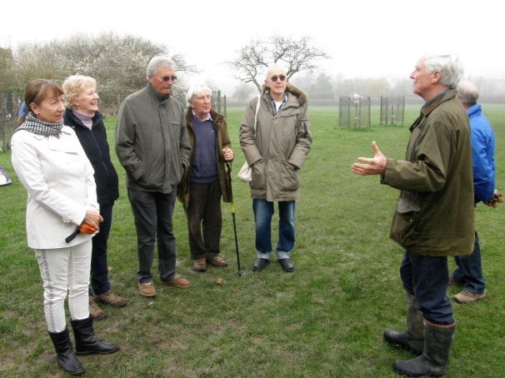

We were very pleased to see all the Spring bulbs and flowers we have planted flowering for the first time. Snowdrops and Crocus were followed by Primroses and Wild Daffodils. These are planted in the unmown grassy areas to each side of the Community Orchard.
We were especially pleased to see the Wild Daffodils (also known as Lent Lillies) flowering, These were donated and planted by Debbie Wood and her family last Autumn in memory of their sister Sheila Davis. They are said to be slow to establish, but over 100 were in full flower in their first year in late March. Hopefully they will continue to thrive and spread in years to come. Wild Daffodils are our native Daffodil, and are now quite rare, being restricted mainly to ancient woodlands, So it is great that we were able to introduce some to our Orchard 'wild' area.

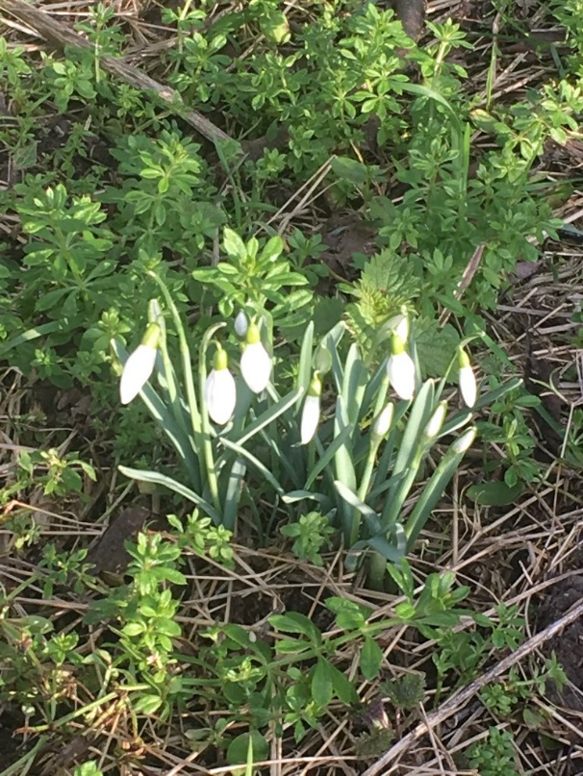
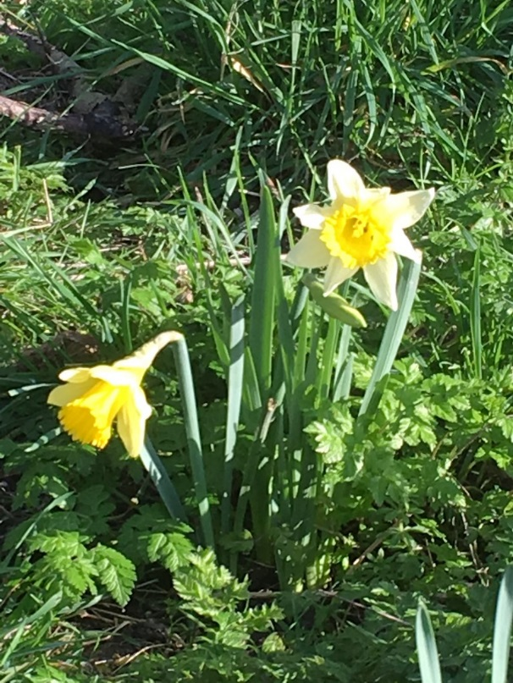

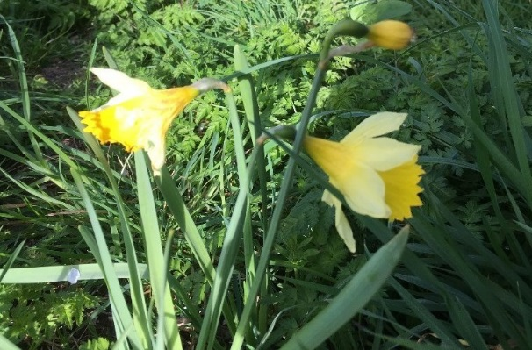
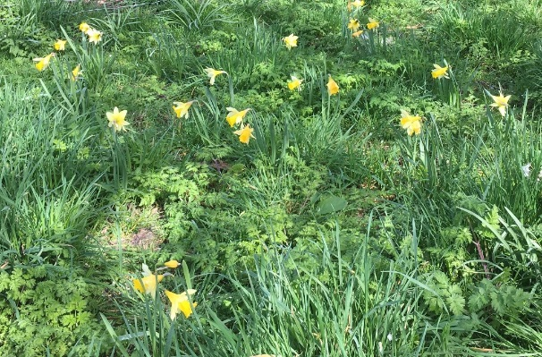

Steyning Downland Scheme &
SCO Children's Orchard and Wild Play Area

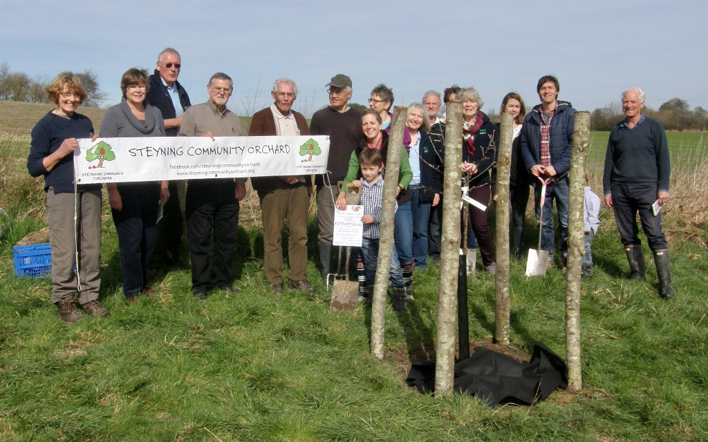
Steyning Downland Scheme/SCO Children's Orchard and Wild Play Area
The Steyning Community Orchard in partnership with the Steyning Downland Scheme has begun planting fruit trees in an area near the Big Picnic Field on the Rifle Range, to create an Orchard which will be both fenced to keep dogs out, and provide a children's wild play area.
All the trees will be on semi-dwarfing rootstocks, so that the fruit will be within easy picking reach for children.
On a sunny day in early March, members of the Steyning Downland Scheme and the Steyning Community Orchard gathered to plant the first three trees in the new Orchard. Each will produce fruit of a different taste, colour and ripening season. Greensleeves is a sweet, golden yellow apple which is picked in September. Idared is a crisp, sweet red apple picked in early October whilst Cheerfull Gold is ready in late October, and has an intense sweet/sharp Cox-like flavour and is a bright red colour.
Each tree has the same cage protection as the trees on the MPF Community Orchard. In this location, the main threat to these young trees is from rabbits and deer. So the trees need protection from both.
More plantings are planned over the next few years, together with the development of the Wild Play area.
Many thanks to the Wiston estate, and Richard Goring in particular, for enthusiatically allowing us to plant fruit trees on their land - and to help us plant the first trees !

"Orchard Sessions" for young people
This summer we would like to see more young people enjoying, sharing, and
learning about our orchard project. We are aiming at everyone from pre-school age
to teenagers. We are offering ‘orchard sessions’ to local schools, pre-schools, and
youth groups, inviting them to bring their young people along to the Memorial Field
orchard to join us for a range of fun activities including craft work, games and
storytelling. We want the groups to learn a little bit about the history of the orchard, to
find out about the trees we have planted and understand why the orchard is
important, in the hope that this will give them a sense that the orchard belongs as
much to them as anyone else.
If you are interested in one of our orchard sessions for a group of children please
contact us by email steyningorchard@gmail.com and we will get in touch with you.

Primrose Court Old Orchard
This is the Orchard in the garden of Primrose Court sheltered accommodation at the junction of Goring Rd and Clays Hill. Years ago this was an orchard of 50 or more trees, but over time most have disappeared. We have been working with the current Development Manager and some of the residents to re-establish an orchard here and have cleared large areas of the undergrowth and planted 12 new trees.
The latest of these were 4 more apple trees that we planted in February. The varieties were Alfriston, Sunset, Blenheim Orange and Worcester Pearmain.

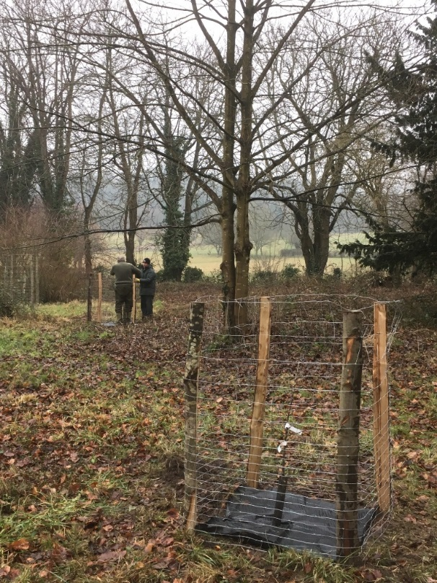
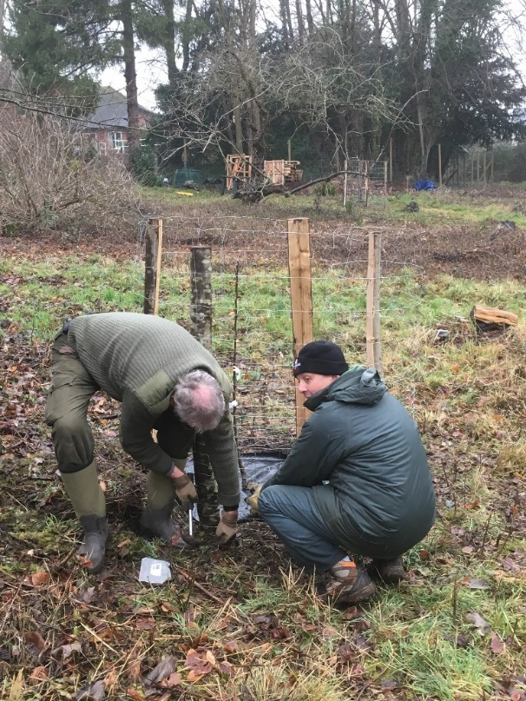

Steyning Fruit Map

We have asked you to let us know about your fruit trees so we can add them to our Orchard Map of Steyning. So far we have 45 different sites with 97 apple trees of 43 different varieties. There are also 13 pear trees and 14 plums and a range of other fruit and nut trees both private and in public spaces. These are shown on the map below with green pins for the public trees and red pins for private. Please be aware that the private locations are not exact.
So the map is coming along nicely but it would be great to see even more pins on our map so please get in contact with us via steyningorchard@gmail.com if you have trees to register!

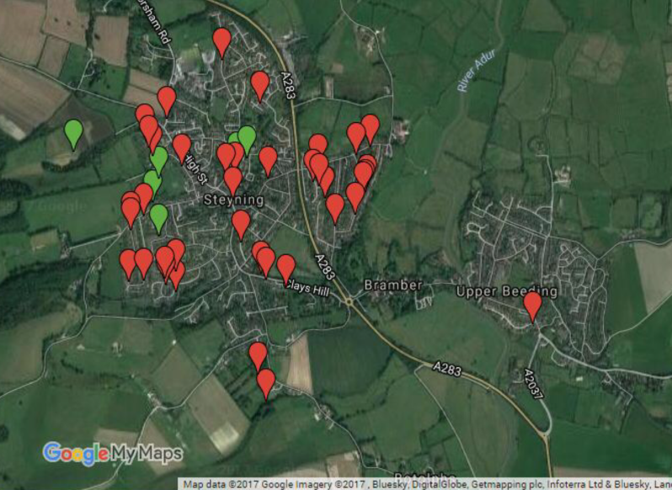

!! MISTLETOE !!

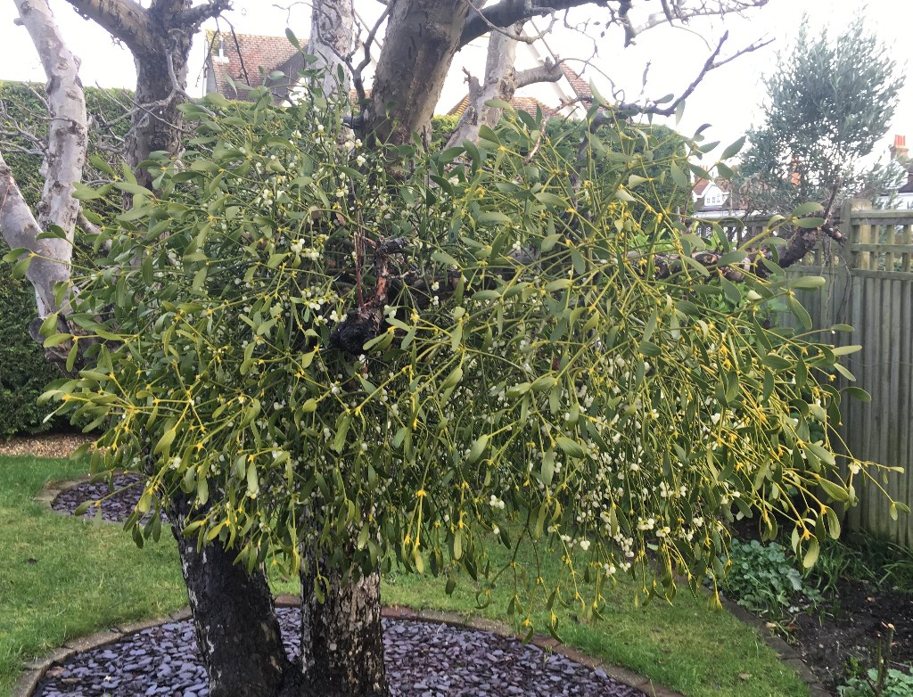
In the last Newsletter we asked if anyone had any Mistletoe in their garden. The owner of this this apple tree near Goring Road contacted us, and we found it still covered in berries in February. The owner kindly let us take some berries, and these have now been used to innoculate trees all over Steyning, including some more on the Community Orchard !
Mistletoe is a fascinating plant with countless myths, beliefs and customs surrounding it. We will investigate this more in a later Newsletter.

If you were wondering who runs the Steyning Community Orchard, we thought it was about time we told you! These are the current members of the SCO Steering Group. (with their specific responsibilities, but we all chip in as needed)
Alec Harden. Our leader and spokesperson.
Roger Brown. Tree planter and main Apple Day organiser
Simon Zec. Local Tree surgeon (with chain saw!). Social Media.
Bob Platt. Publicity/photography.
Ronnie Reed. Children's activities
Lou Mandry. Steyning Fruit Map project
Sarah Sullivan. Councillor. Parish Council liaison.
Dave Buckett. Helps with everything. Steyning Downland Scheme liaison
Richard Hopkins. Our newest member and treasurer.
We can all be contacted via steyningorchard@gmail.com

We will have a stall at the Steyning May Fair on 29th May. Do come and say hello..!

Website

Please take a look at our website www.steyningcommunityorchard.org. It includes details of all our Orchards, and the fruit trees we have planted in them. It also has up-to-date news feeds from Facebook and Twitter, so you can follow us even if you don't use these social media.

The next Newsletter will be published in June.
Any comments, suggestions, feedback, please email us on :-
steyningorchard@gmail.com







Copyright © 2017 Steyning Community Orchard, All rights reserved.
You are receiving this email because you have opted in to the Steyning Community Orchard mailing list.
Our mailing address is:
Steyning Community Orchard
87 Kings Stone Avenue
Steyning, West Sussex BN44 3FJ
United Kingdom
Add us to your address book
Want to change how you receive these emails?
You can update your preferences or unsubscribe from this list


